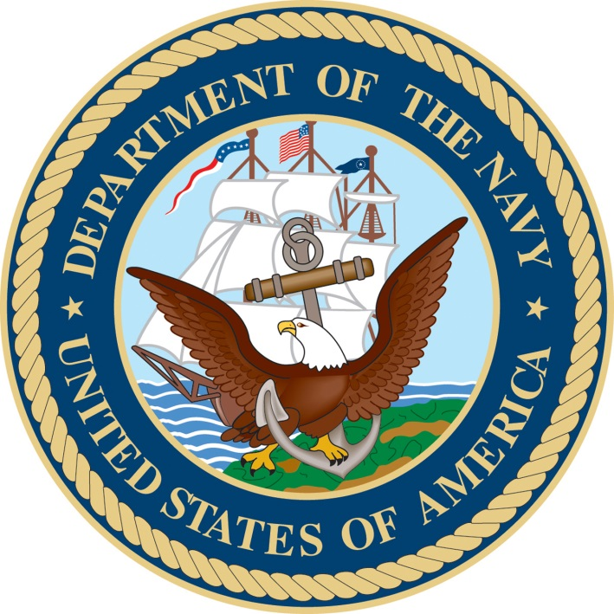

NAVAL STATION NORFOLK
WELCOME ABOARD PACKAGE

From: Unaccompanied Housing Installation Program Director; Naval Station Norfolk
To: New Residents of Unaccompanied Housing

SUBJ: WELCOME ABOARD NAVAL STATION NORFOLK

1. Congratulations on your assignment to Naval Station Norfolk! We welcome you, and are humbled at the opportunity to provide you accommodations while you complete your mission. Our goal is to provide stellar service, and to ensure that our facilities are the safest and most comfortable in the Navy. Your feedback is always welcome (and encouraged!)

2. The intention of this package is to inform you of the rules, regulations, and responsibilities we all have to ensure our program runs as efficiently as possible. It is a collective effort, and there are expectations on both management and the resident in order for us to achieve success.

3. While residing in our facilities, we hope that you make it your home away from home. If for any reason you have a concern, our Building Managers are trained and eager to remedy. There are periodic inspections of the rooms so that we may ensure that everyone is doing their part in maintaining the overall facility conditions.

4. Each facility has designated Resident Advisors (RA’s) that act as a first line of defense for any concerns our residents may have. You are absolutely encouraged to maintain an open communication channel with them as they can assist in a multitude of ways. Shortly after check-in your assigned RA will introduce themselves and provide you contact information.

5. Thank you for your service! I am extremely grateful for all that you do, and I stand by to assist in making your accommodations onboard Naval Station Norfolk second to none.
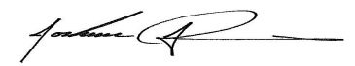

J. R. Adelman

History of Naval Station Norfolk

The land on which Naval Station Norfolk is located was originally the site of the 1907 Jamestown Exposition. During this exposition, high-ranking naval officers were consulted and favored the idea that this site was ideal for a naval base. A bill was passed in 1908 proposing that Congress appropriate $1 million for the purchase of the property and buildings, but it dies when the Assistant Secretary of the Navy was given a choice between this property and a new coal ship. He replied that a new ship was an absolute necessity.

Immediately after the United States entered World War I in April 1917, the Secretary of the Navy was persuaded to buy the property. A bill was passed for the purchase of 474 acres. It also set aside the sum of $1.6 million for development of the base, including piers, aviation facilities, storehouses, and facilities for fuel, oil storage, a recruit training station, a submarine base, and recreation areas for fleet personnel. The next six months saw the establishment of the Fifth Naval Headquarters, the Naval Operating Base (NOB), Naval Training Station Naval Hospital, and Submarine Station. By Armistice Day, 1918, there were 34,000 enlisted men at the base.

An airfield for seaplanes was established at the Naval Operating Base in October 1917. In August 1918 it was detached from NOB and Became Naval Air Station (NAS) Hampton Roads. It was renamed NAS Norfolk in 1921.

During WWI the Navy concluded that the available land was insufficient. It was decided to fill a large part of the flats on the west and north by dredging the Elizabeth River to a depth sufficient for large ships to dock at NOB. During the fall and winter of 1917, approximately eight million cubic yards was dredged, moving the northern shoreline from along Dillingham Boulevard to approximately its current location.

During the late thirties and early forties, much construction took place at the Naval Operating Base and Naval Air Station as war loomed on the horizon. New buildings and piers were constructed and new runways, hangars, and ramps were constructed for the large land planes and seaplanes flown by the Navy in World War II. In December 1942, recruit training at the base was discontinued in order to focus on advanced training for men going directly to the fleet.

The Naval Operating Base and Naval Air Station, then collectively referred to as Naval Base Norfolk continued their significant role as the home of the Atlantic Fleet after World War II. In January 1953, Naval Operating Base Norfolk was renamed Naval Station Norfolk as part of a Navy effort to standardize base names. On February 5, 1999, NAS Norfolk was disestablished and Chambers Field became part of Naval Station Norfolk. Today, in addition to being the home of the Navy’s largest concentration of naval forces, Naval Station Norfolk also hosts personnel from the Marine Corps, Army, Air Force, and Coast Guard, and supports Joint missions as well.

UH STAFF AND POINTS OF CONTACT area code (757)

Installation Program Director 444-8036
Naval Station Norfolk Unaccompanied Housing Manager 445-9904
Site Leading Chief Petty Officer 445-0993
Site Leading Petty Officer 445-0158
Central Billeting Barracks 322-9500
Base Quarterdeck 322-2366
Duty Complex Manager 438-4036

EMERGENCY NUMBERS area code (757)

Fire and Emergency Rescue 444-3333
Military Police (Emergency) 444-2324
Sewell’s Point Branch Medical Clinic 953-8881
Chapel 445-1574
Duty Chaplain 322-2366/2365
Suicide Prevention 444-0147/445-1574
Sexual Assault Prevention 438-3504
DoD Safeline 877-995-5247

OTHER IMPORTANT PHONE NUMBERS area code (757)

Base Information 444-0000
Navy Relief 322-1171/3134
American Red Cross 440-1111
Fleet Family Support Services 444-2102
Housing Office/Rentals/Family/Home buying 1-800-628-7510
Legal Office 444-5300/5053
Naval Station Norfolk Galley 444-1491
Helpline 1-800-273-8255

Base Maps are posted at each quarterdeck
Bus schedules are available at each quarterdeck

UNACCOMPANIED HOUSING BUILDING NUMBERS area code (757)
X-2 (WILLIS MANOR) - 24 HOUR FRONT DESK - 322-1012/1015
X-1 (MONSOOR MANOR) 322-9369
R-63(PENN HALL) RENOVATION
IB (ENTERPRISE HALL) 444-0682
R-61 (SCHAMBERGER HALL) RENOVATION
O-22 (GROSHONG HALL) 322-9500
U-112 (MAYO HALL) RENOVATION
KJ (INTREPID HALL) 444-6329
KK (CONSTELLATION HALL) 445-9546
KL (INDEPENDENCE HALL) 444-9059
KM (LEXINGTON HALL) 444-0584
KQ (SARATOGA HALL) 444-8526
IF (BULLARD HALL) 444-4024

BASE ACTIVITIES INFORMATION

Dining Facilities
Naval Station Norfolk Base Galley (Ships Cabin)
1650 Gilbert Street (BLDG. IAA) | (757) 444-1491

Breakfast: 0600 – 1000 (Monday through Friday)
0800 – 1100 (Weekends and Holidays)
Lunch: 1000 – 1400 (Monday through Friday)
1100 – 1400 (Weekends and Holidays)
Dinner: 1400 – 1730 (Monday through Friday)
1400 – 1730 (Weekends and Holidays)

- Price for meals are:
  - (Personnel Receiving Basic Allowance for Subsistence – BAS); Standard meal rate
  - Ration-in-Kind (RIK) customers eat for free with valid CAC ID card
Meals include a 21 item salad bar. Service is for all active duty service members, dependents and all personnel authorized government messing.
Naval Station Norfolk Galley now accepts Visa, Master Card, AMEX, and Discover cards. No signature required for purchases under $25.

NAVY EXCHANGE NORFOLK
1560 Mall Drive, Norfolk, VA 23511-3839 | (757) 440-2000
Hours of Operation: Monday - Saturday: 0900 – 2100; Sunday: 0900 – 1900; Closed Federal Holidays

COMMISSARY
1588 Mall Drive, Norfolk, VA 23511-2895 | (757) 423-6070
Hours of Operation: Monday - Saturday: 0900 – 2000; Sunday: 0900 – 1900; Closed Federal Holidays

GYMNASIUMS
N-24 | (757) 444-0629
(BASKETBALL, TENNIS, VOLLEYBALL, INDOOR WEIGHTS, FITNESS CENTER)
Hours of Operation: Monday – Friday: 0500 – 2000; Saturday & Sunday: 0900-1600

CEP-58 (MCCORMICK) | (757) 444-4016
(BASKETBALL, TENNIS, VOLLEYBALL, INDOOR WEIGHTS, FITNESS CENTER)
Hours of Operation: Monday – Friday: 0500 – 2200; Saturday & Sunday: 0900-2100

Q-80 (WATERFRONT) | (757) 444-1267
(BASKETBALL, TENNIS, INDOOR TRACK, VOLLEYBALL, INDOOR WEIGHTS, FITNESS CENTER, POOL)
Hours of Operation: Monday – Friday: 0500 – 2200; Saturday & Sunday: 0900-2100

C-9 WIND & SEA COMPLEX | (757) 440-2009
(POOL TABLES, MOVIE ROOM, PING PONG, VIDEO GAMES, WIFI, COMPUTERS)
Hours of Operation: Monday – Friday: 1100 – 2100; Saturday & Sunday: 1200-1900

- BARBER SHOP: (757) 440-2235
Monday – Friday: 0800 – 1700; Saturday & Sunday: 1200-1900
- FOOD COURT: (757) 440-2026
Monday – Sunday: 1000-2200
- MINI MART: (757) 440-2009
Monday – Friday: 0700 – 2200; Saturday & Sunday: 1000-1800
- POST OFFICE: (757) 444-2043
Monday – Friday: 0700 – 2200; Saturday & Sunday: CLOSED

BOWLING ALLEY | (757) 451-0600
Inside gate #5
Hours of Operation: Monday – Sunday: 0900-2300

MAIN GATE MOVIE THEATER | (757) 445-5304
Located across from NEX
CALL FOR TIMES!

MINI MARTS:
W-313 | (757) 440-2064
Hours of Operation: Monday – Friday: 0530 – 2200; Saturday & Sunday: 0700-2000

CEP-76 | (757) 440-2315
Hours of Operation: Monday – Friday: 0600 – 1830; Saturday & Sunday: 1000-1600

V-57 | (757) 440-2917
Hours of Operation: Monday – Friday: 0600 – 1900; Saturday & Sunday: 0900-1600

AUTO PORT | (757) 440-2848/2268
Located at U-126
Hours of Operation: Monday – Friday: 0700 – 1600; Saturday: 0800-1600; Sunday: CLOSED

NON-GOVERNMENT AFFILIATED SERVICES

COX CABLE | (866) 961-0027 NORFOLK CHECKER TAXI | (757) 855-6612
(INTERNET, PHONE, CABLE TELEVISION) (NAVSTA NORFOLK ACCESS)
AT&T | (800) 331-0500 BLACK & WHITE CABS | (757) 853-0411
(CELLULAR SERVICE) (NAVSTA NORFOLK ACCESS)
VERIZON | (800) 922-0204 HAMPTON ROADS TRANSIT | (757) 222-6000
(CELLULAR SERVICE) (NAVSTA NORFOLK ACCESS)

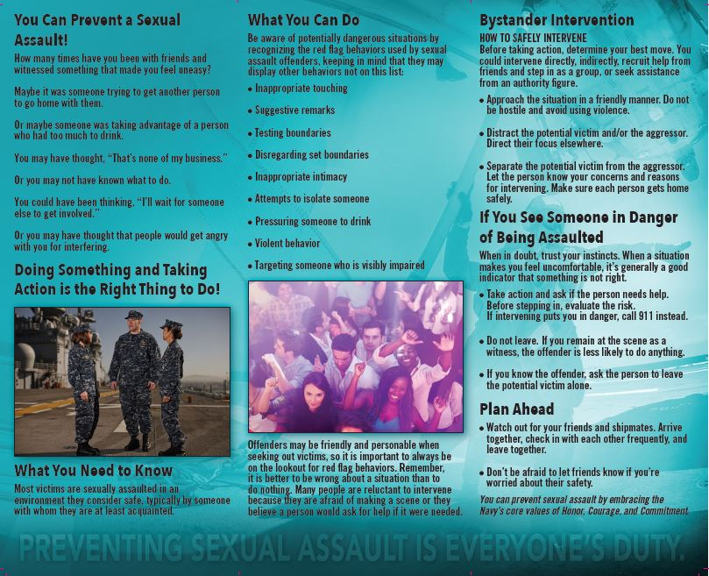

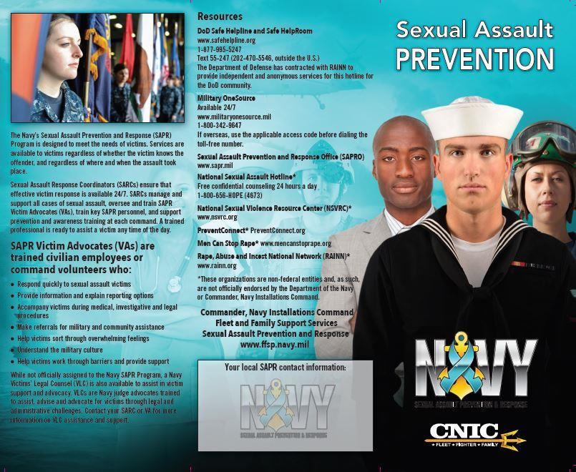

NAVAL STATION NORFOLK
24/7 HOTLINE
757-438-3504

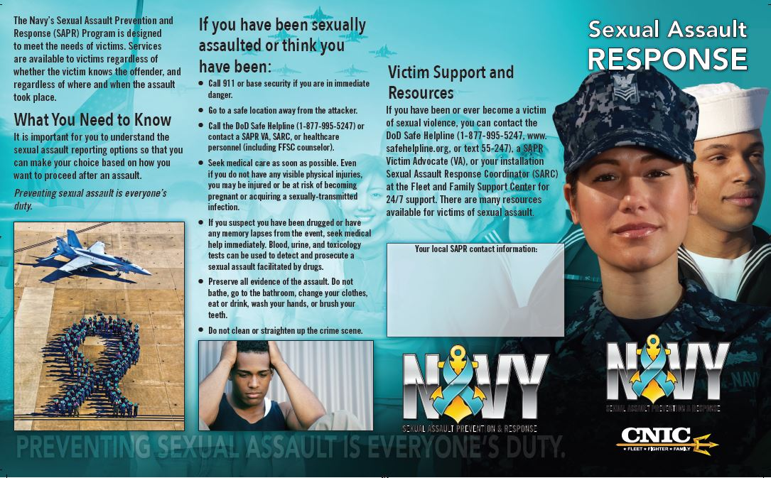

NAVAL STATION NORFOLK
24/7 HOTLINE
757-438-3504

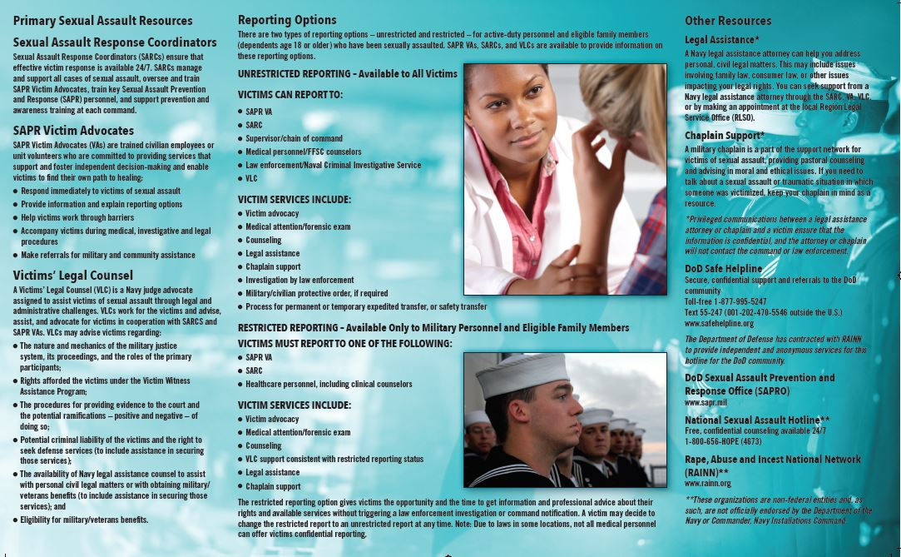

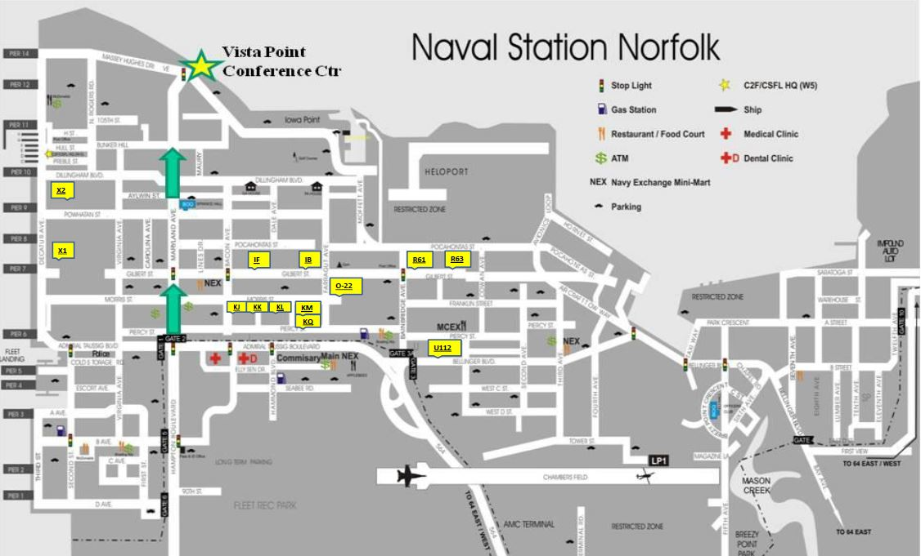

FIRE PROTECTION
- Fire alarms are located throughout each facility, ensuring adequate coverage in our rooms and common spaces. Residents will need to familiarize themselves with the nearest fire alarm / pull station as well as the evacuation plan posted In the event of an actual emergency residents should pull the nearest alarm and seek safety outside. Once safe they should immediately call:
757-444-3333
- Remember, it is the responsibility of all personnel to report a fire. Residents should never wait as lives are at stake.
- In the event of an actual fire do not use elevators. Residents should plan accordingly and have a secondary escape route.
- Treat all fire alarms as an actual emergency.
- Every room has a smoke detector installed. Although Building Managers will periodically ensure the detector is working, residents are expected to also check their detectors monthly.
- Residents who intentionally modify or disable any smoke detector will face disciplinary actions.

AUTHORIZED SMOKING AREAS
- Smoking, vaping, and smokeless tobacco are prohibited in Unaccompanied Housing and residents will refrain from smoking within 50 feet of any entry/exit point.
- Each UH facility has a designated exterior smoking area for residents.
- Residents are expected to clean up after themselves (i.e. no cigarette butts, trash, etc.) while utilizing these areas. Failure to do so may result in disciplinary action.

VEHICLES
- Each UH facility has an assigned parking lot which residents are expected to use. Adjacent lots are not available to residents and are to be used by the occupying activity only.
- Residents will not conduct maintenance or repairs in the parking lots. The Building Managers can provide information on MWR locations where residents can perform these activities.
- Bike racks are available to residents who wish to secure their bicycles. Residents are responsible for maintaining the condition of their property.

TROUBLE CALL PROCEDURES
Residents that require maintenance assistance should notify their assigned Resident Advisor and Building Manager immediately. After hours call may be directed to:
Duty Complex Manager (757) 438-4036
- Unaccompanied Housing maintenance will respond depending on severity, but no later than 1 working day after submission.
- Unaccompanied Housing staff will keep the resident informed of the status of the trouble call request.
- Any concerns with regards to A/C or heat, the Duty Complex Manager will notify the CDO and Chain of Command for further assistance.
- Residents are encouraged to notify management of any material deficiency with the furniture in their assigned spaces as well as any issues that may be present with the appliances.

LAUNDRY AREAS
- Every UH facility has washing machines and dryers for residents to use.
- Guests are not permitted to utilize the laundry facilities.
- Residents are solely responsible for their personal property.
- After each use, the resident is expected to clean up after themselves, ensuring there are no detergent spills or lint remaining in the machines.

DAY SLEEPERS
- Personnel who are designated “Day Sleepers” will inform their Building Manager or the front desk personnel to get an approved “Day Sleeper” pass.
- Authorized “Day Sleepers” room inspections will occur after 1300
- Any routine maintenance conducted by Unaccompanied Housing staff will occur after 1300
- Work requiring access prior to 1300 will be coordinated with the resident unless it is an emergency.
- Residents who are assigned roommates that are day sleepers are to make every effort to not disturb them.

DISASTER AWARENESS PLAN
The Tidewater Regions of Virginia experience several different forms of destructive weather throughout the year. Meteorological data indicates however; hurricanes and tropical storms are the most serious in terms of destructive potential. Although the hurricane season runs from 01 June through 30 November, it is possible for these storms to strike outside of this window. Storms of non-tropical origins such as frontal passages, local thunderstorms and tornadoes occur more frequently in the area however; are limited in their destructive potential. Advance planning, especially in the event of a hurricane or tropical storm will minimize loss of life, destruction of property and disruption of operations.
If inclement weather is anticipated, residents should monitor the following outlets:
- National Weather Hurricane Center: http://www.nhc.noaa.gov
- Weather Channel http://www.weather.com
- Virginia Evacuation Routes http://virginiadot.org/travel/hurricane

Hurricane Quick Reference:
  - - Hurricane > 63 Knots
  - - Tropical Storm 34 – 63 Knots
  - - Tropical Depression < 34 Knots (Closed Circulation)
  - - Tropical Disturbance < 34 Knots (No Closed Circulation)
  - - Tropical Cyclone Conditions Time to onset of 50 Knot winds.
Conditions of Readiness (COR):
  - Condition V 96 hours until storm arrives
  - Condition IV 72 hours until storm arrives
  - Condition III 48 hours until storm arrives
  - Condition II 24 hours until storm arrives
  - Condition I 12 hours until storm arrives
Giant Voice:
- Naval Station Norfolk is equipped with a public address system that will provide details in the event of an emergency.
- Residents should familiarize themselves with the tone system for specific threats

RESIDENT REPORTING
Unaccompanied Housing staff will consistently make every effort to ensure that all residents are comfortable and safe in their assigned facilities. If at any time residents are uncomfortable or are concerned for the wellbeing of themselves or another resident they should contact:
- Base Police if it is an emergency – (757) 444-3333
  - Assault, vandalism, other emergency situations
- The assigned Resident Advisor; their contact information should be available in each of the rooms within the facility
  - Excessive noise, tobacco/alcohol misuse, unauthorized visitors, facility concerns
- Building Management
  - Any issues or concerns that have not been resolved at the Resident Advisor (RA) level

